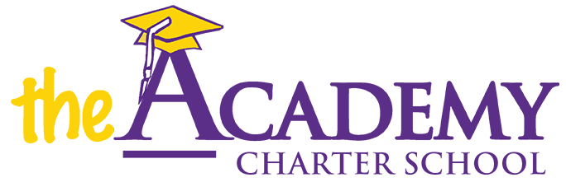
Nassau County District Transportation Application and Information
Baldwin
Bellmore
Carle Place
East Meadow
East Rockaway
East Williston
Elmont
Farmingdale
Floral Park-Bellerose
Franklin Square
Freeport
Garden City
Glen Cove
Great Neck
Hempstead
Herricks
Hewlett-Woodmere
Hicksville
Island Park
Island Trees
Jericho
Lawrence
Levittown
Locust Valley
Long Beach
Lynbrook
Malverne
Manhasset
Massapequa
Merrick
Mineola
New Hyde Park
North Bellmore
North Merrick
North Shore
Oceanside
Plainedge
Plainview-Old Bethpage
Rockville Centre
Roosevelt
Roslyn
Seaford
Sewanhaka Central
Syosset
Uniondale
Valley Stream
Wantagh
West Hempstead
Westbury

