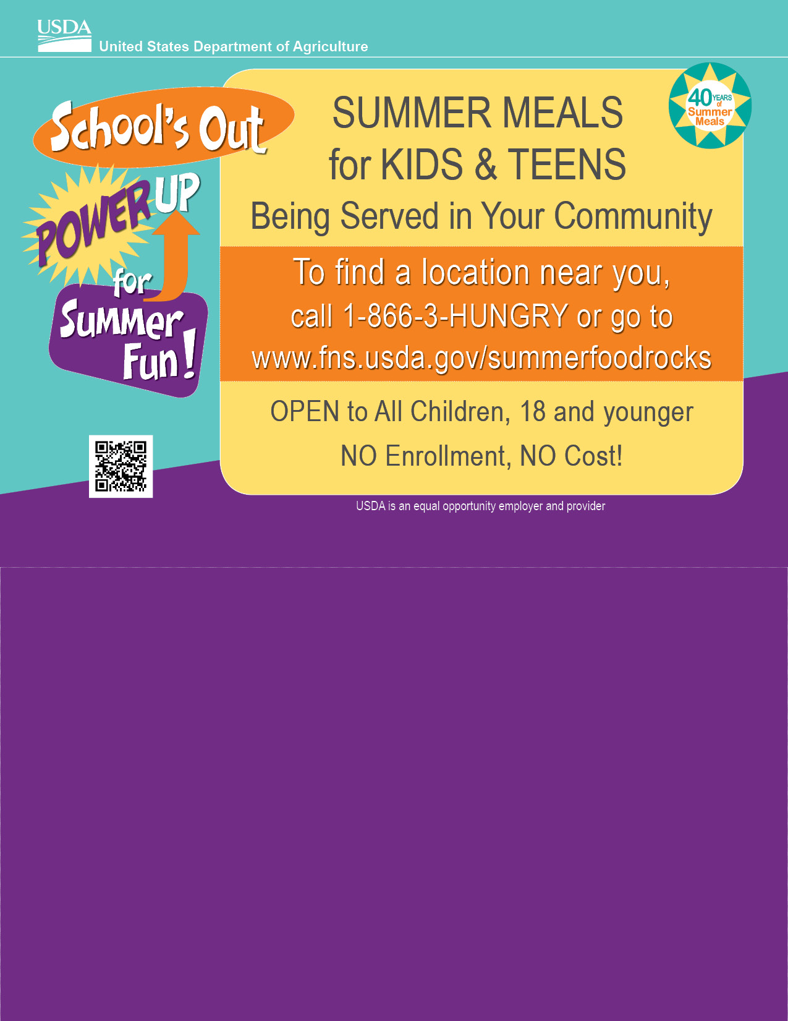

As part of our long-standing tradition of serving our community The Academy Charter School will once again be providing free summer meals (breakfast and lunch) for children 18 years and younger. We encourage you to be a part of this experience!

Start Date: July 6, 2026
End Date: Aug 1, 2026
HS End Date: AUG 20, 2026

Meals Available: Breakfast & Lunch: 8:30 AM till 1PM

Our Location: HS 127 N. Franklin Street
Hempstead, NY 11550 (Ends 8/19)
100 Charles Lindbergh Blvd.
Uniondale, NY 11550
117 N. Franklin Street
Hempstead NY 11550
ACS Uniondale Campus
100 Charles Lindbergh Ave
Uniondale NY 11553

For more information, please feel free to contact us
516-408-2200

